**22AIE303 –**

**LABSHEET 6**

Name : Anuvind M P

Roll no : AM.EN.U4AIE22010

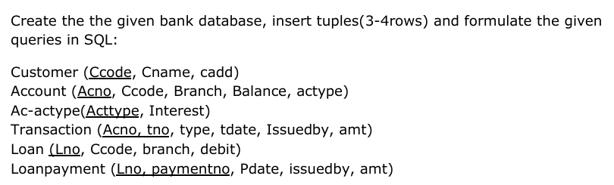

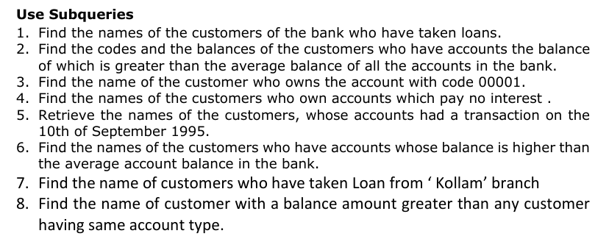

1. CREATE TABLE Customer ( Ccode VARCHAR(10) PRIMARY KEY, Cname VARCHAR(50), Cadd VARCHAR(100) );
2. CREATE TABLE Account ( Acno VARCHAR(10) PRIMARY KEY, Ccode VARCHAR(10), Branch VARCHAR(50), Balance DECIMAL(10, 2), Actype VARCHAR(20), FOREIGN KEY (Ccode) REFERENCES Customer(Ccode) );
3. CREATE TABLE Ac_actype ( Actype VARCHAR(20) PRIMARY KEY, Interest DECIMAL(5, 2) );
4. CREATE TABLE Transaction ( Acno VARCHAR(10), Tno VARCHAR(10) PRIMARY KEY, Type VARCHAR(10), Tdate DATE, Issuedby VARCHAR(50), Amt DECIMAL(10, 2), FOREIGN KEY (Acno) REFERENCES Account(Acno) );
5. CREATE TABLE Loan ( Lno VARCHAR(10) PRIMARY KEY, Ccode VARCHAR(10), Branch VARCHAR(50), Debit DECIMAL(10, 2), FOREIGN KEY (Ccode) REFERENCES Customer(Ccode) );
6. CREATE TABLE Loanpayment ( Lno VARCHAR(10), Paymentno VARCHAR(10) PRIMARY KEY, Pdate DATE, Issuedby VARCHAR(50), Amt DECIMAL(10, 2), FOREIGN KEY (Lno) REFERENCES Loan(Lno));

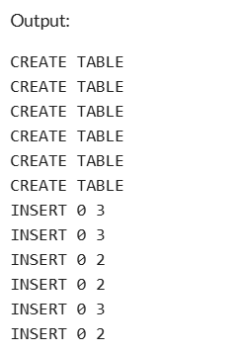

1. INSERT INTO Customer (Ccode, Cname, Cadd)

VALUES

('C001', 'John Doe', '123 Elm St'),

('C002', 'Jane Smith', '456 Oak St'),

('C003', 'Mary Johnson', '789 Pine St');

1. INSERT INTO Account (Acno, Ccode, Branch, Balance, Actype)

VALUES

('A001', 'C001', 'New York', 5000, 'Savings'),

('A002', 'C002', 'Chicago', 15000, 'Checking'),

('A003', 'C003', 'New York', 7000, 'Savings');

1. INSERT INTO Ac_actype (Actype, Interest)

VALUES

('Savings', 2.5),

('Checking', 0.0);

1. INSERT INTO Loan (Lno, Ccode, Branch, Debit)

VALUES

('L001', 'C001', 'Kollam', 2000),

('L002', 'C003', 'Chicago', 5000);

1. INSERT INTO Transaction (Acno, Tno, Type, Tdate, Issuedby, Amt)

VALUES

('A001', 'T001', 'Deposit', '1995-09-10', 'John Doe', 1000),

('A002', 'T002', 'Withdraw', '1995-09-10', 'Jane Smith', 2000),

('A003', 'T003', 'Deposit', '1995-09-09', 'Mary Johnson', 500);

1. INSERT INTO Loanpayment (Lno, Paymentno, Pdate, Issuedby, Amt)

VALUES

('L001', 'P001', '2024-09-01', 'John Doe', 500),

('L002', 'P002', '2024-09-02', 'Mary Johnson', 1000);

1. SELECT Cname FROM Customer WHERE Ccode in (SELECT Ccode FROM Loan);

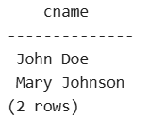

1. SELECT Ccode, Balance FROM Account WHERE balance > (SELECT AVG(balance) FROM Account);

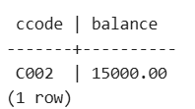

1. SELECT Cname FROM Customer WHERE Ccode = (SELECT Ccode FROM Account WHERE Acno = '0001');

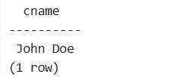

1. SELECT Cname FROM Customer WHERE Ccode IN (SELECT Ccode FROM Account WHERE Actype IN SELECT Actype FROM Ac_actype WHERE Interest = 0.0));

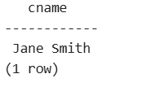

1. SELECT Cname FROM Customer WHERE Ccode IN (SELECT Ccode FROM Account WHERE Acno IN (SELECT Acno FROM Transaction WHERE tdate='1995-09-10'));

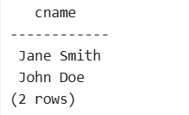

1. SELECT Cname FROM Customer WHERE Ccode IN (SELECT Ccode FROM Account WHERE Balance > (SELECT AVG(Balance) FROM Account));

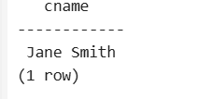

1. SELECT Cname FROM Customer WHERE Ccode IN (SELECT Ccode FROM Loan WHERE Branch = 'Kollam');

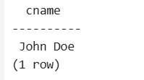

1. SELECT Cname FROM Customer WHERE Ccode IN (SELECT Ccode FROM Account A1 WHERE Balance > ALL (SELECT Balance FROM Account A2 WHERE A2.Actype = A1.Actype AND A2.Ccode <> A1.Ccode));

